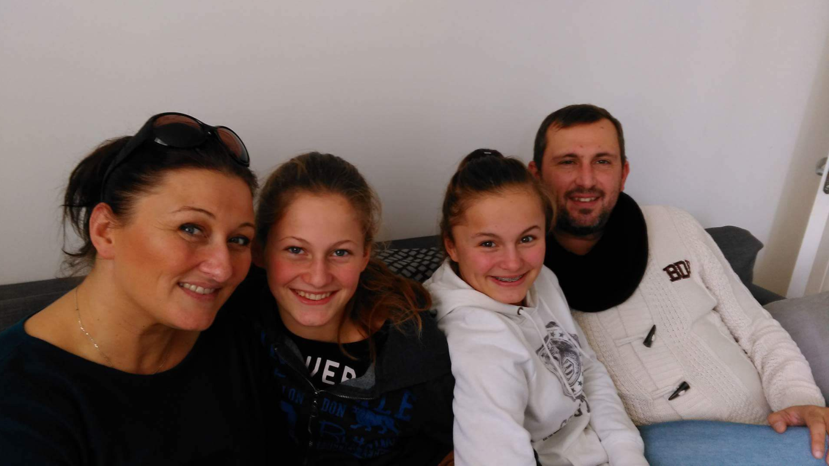
Hello, I’m Christophe DECROIX, the teacher of scientist and chemist for the Lycée Anatole France.
I’m fourty three , i have two daughters Céleste (14 years) and Faustine (12 years).
My wife is Dorothée, she ‘s a policewoman.
I live in Anvin (20 km from Lillers), a lovely small town in a quiet place.
I love watching and practise sport (Swimming, jogging, cycling,soccer,…), speaking, learning…
The pupils say about me i’m cool, i’m pleasant but a little bit mocking (for joke).
I love animals, i have ducks, fishes in a little lake at home.
I cook for the family, i hope i could make some french recipe during the trip.
See you next…
My email : decroix.christophe@aliceadsl.fr

