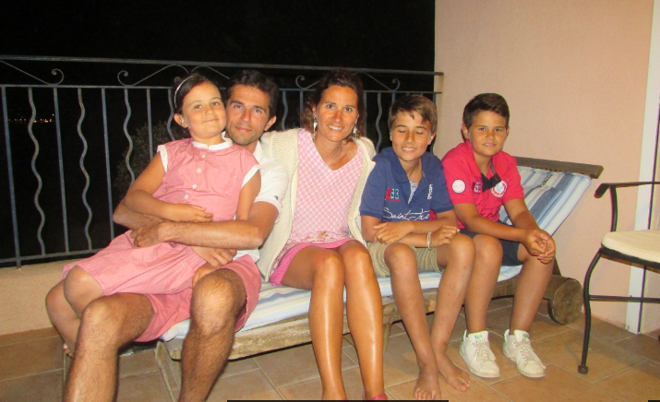

Hello, I’ am François Bricout, the teacher of mathematical for the Lycée Anatole France at Lillers in the north of France.
I am fourty two et have two sons Agustin ( 13 years) , Clément (11 years) and have one daughter Gaelle ( 8 years ). My wife is a professeur too.
We live in Bethune (15 km from Lillers).
I am allergic to mushrooms. I love animals. I like to walk in nature and partise sport (running and soccer).
I do not speak very good English
It is with great pleasure that we come to discover your region.
See you next

François
My mail : francoisbricout@sfr.fr

